NumPy (Numerical Python)
- Creating Arrays
AIM: To write a Python program using NumPy to create a one-dimensional array, two-dimensional array, zeros array, ones array, identity matrix, and range of values.
ALGORITHM:
- Start the program.
- Import the NumPy library.
- Create a one-dimensional array using np.array().
- Create a two-dimensional array using np.array().
- Create a 3 × 3 zeros array using np.zeros().
- Create a 2 × 4 ones array using np.ones().
- Create a 3 × 3 identity matrix using np.eye().
- Generate numbers from 0 to 8 with a step of 2 using np.arange().
- Display all the arrays.
- Stop the program.

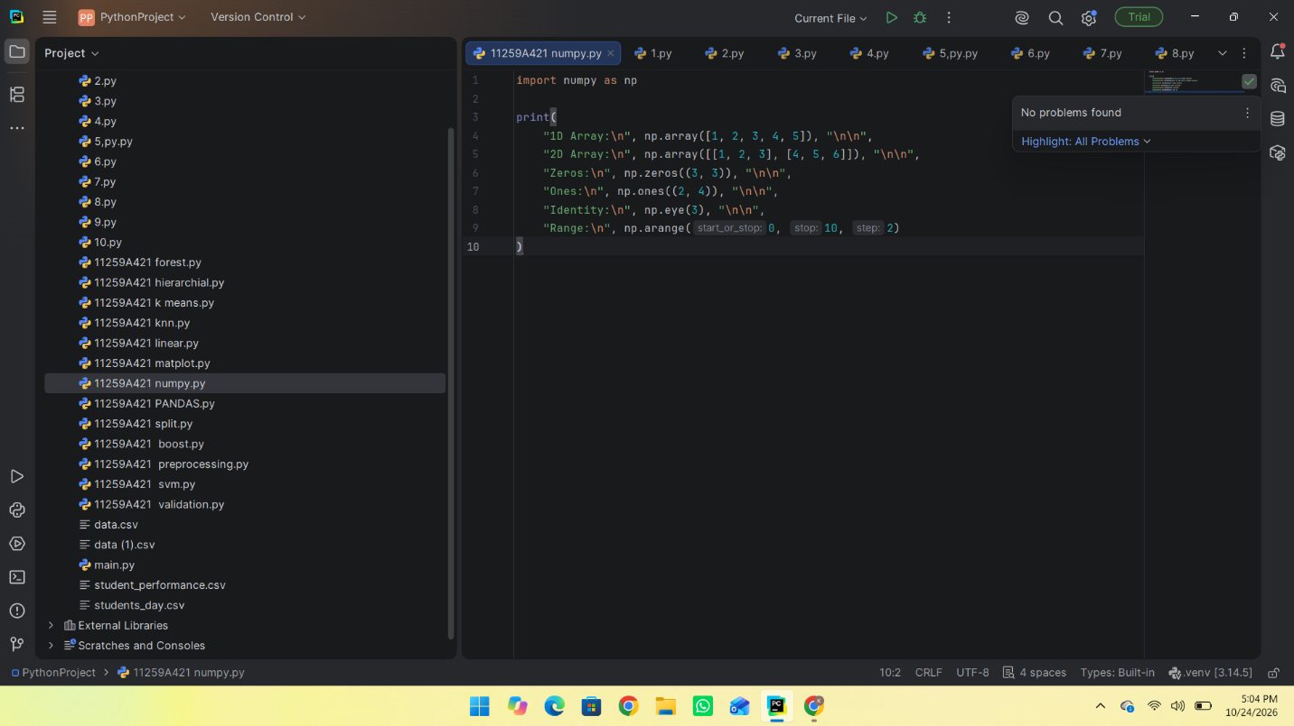

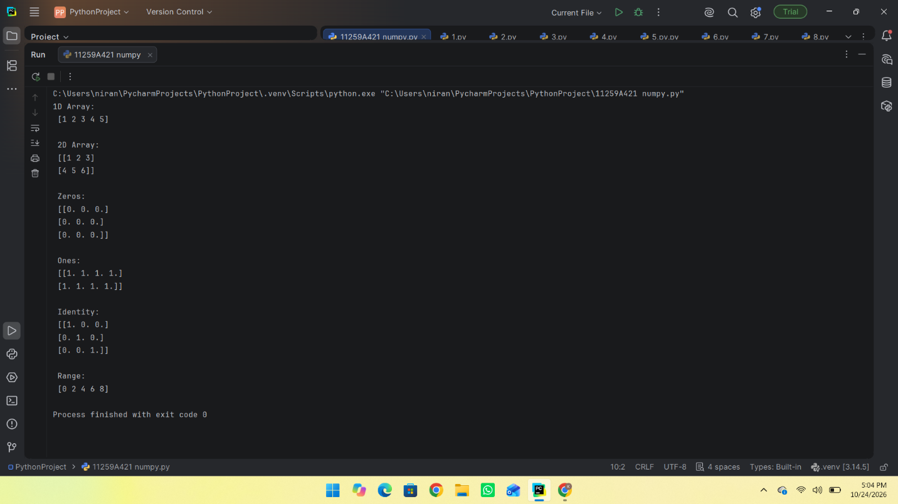
RESULT:
Thus, the Python program to create one-dimensional and two-dimensional arrays, zeros array, ones array, identity matrix, and range of values using NumPy was executed successfully.

- Array Operations
AIM: To write a Python program to perform addition, multiplication, scalar multiplication, square root, mean, and dot product operations using NumPy arrays.
ALGORITHM:
- Start the program.
- Import the NumPy library.
- Create two arrays, a = [1, 2, 3] and b = [4, 5, 6].
- Perform element-wise addition using a + b.
- Perform element-wise multiplication using a * b.
- Multiply each element of array a by 10 using a * 10.
- Calculate the square root of array a using np.sqrt().
- Calculate the mean of array a using np.mean().
- Calculate the dot product of arrays a and b using np.dot().
- Display all the results.
- Stop the program.
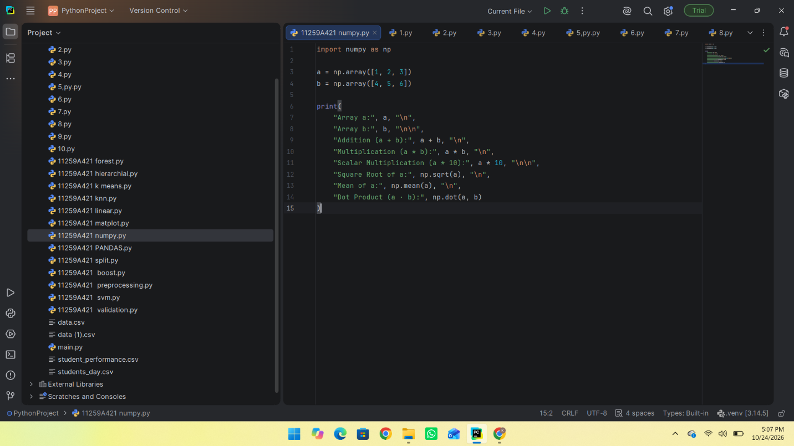
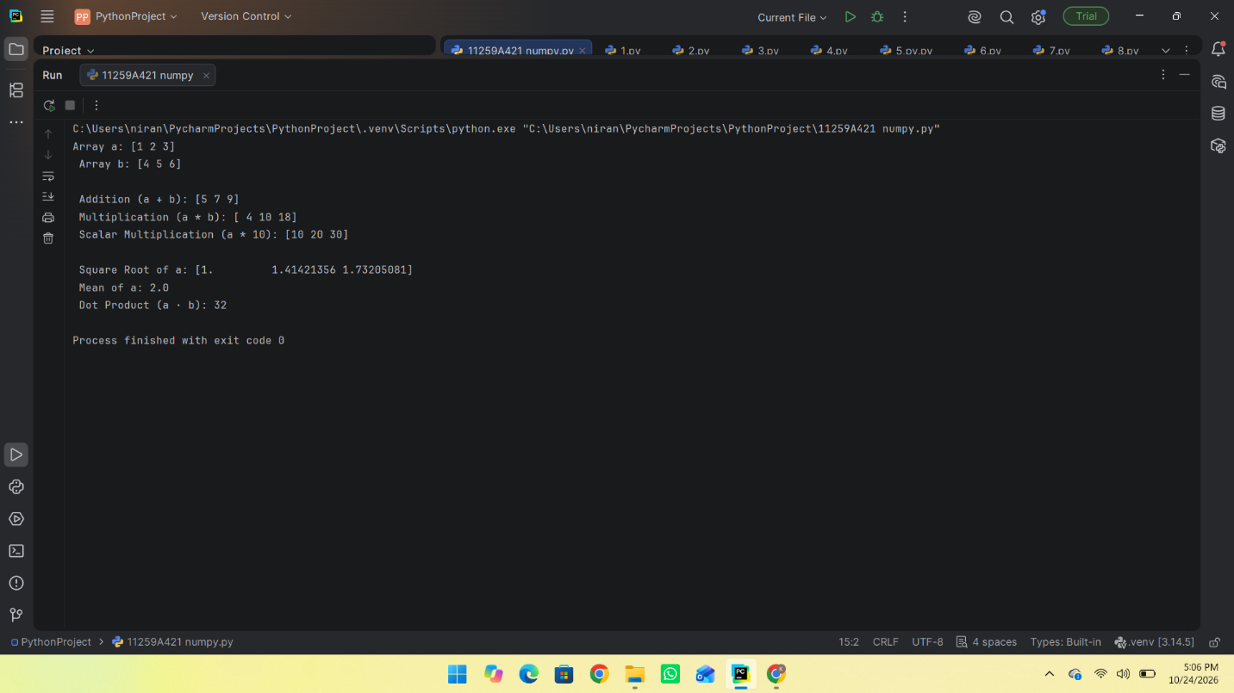
RESULT: Thus, the Python program to perform addition, multiplication, scalar multiplication, square root, mean, and dot product operations using NumPy arrays was executed successfully

- Indexing and Slicing
AIM: To write a Python program to access matrix elements, extract rows and columns, and obtain a sub-matrix using NumPy indexing and slicing.
ALGORITHM:
- Start the program.
- Import the NumPy library.
- Create a 3 × 3 matrix containing the values 10, 20, 30, 40, 50, 60, 70, 80, and 90.
- Display the complete matrix.
- Access and display the element at index [1, 2].
- Extract and display the first row using matrix[0, :].
- Extract and display the second column using matrix[:, 1].
- Extract and display the top-left 2 × 2 sub-matrix using matrix[0:2, 0:2].
- Stop the program.
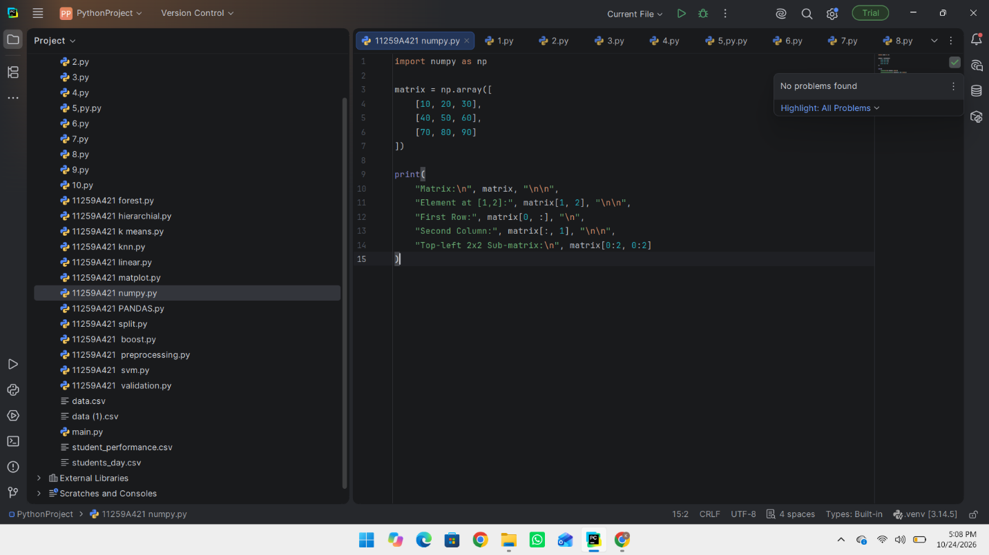
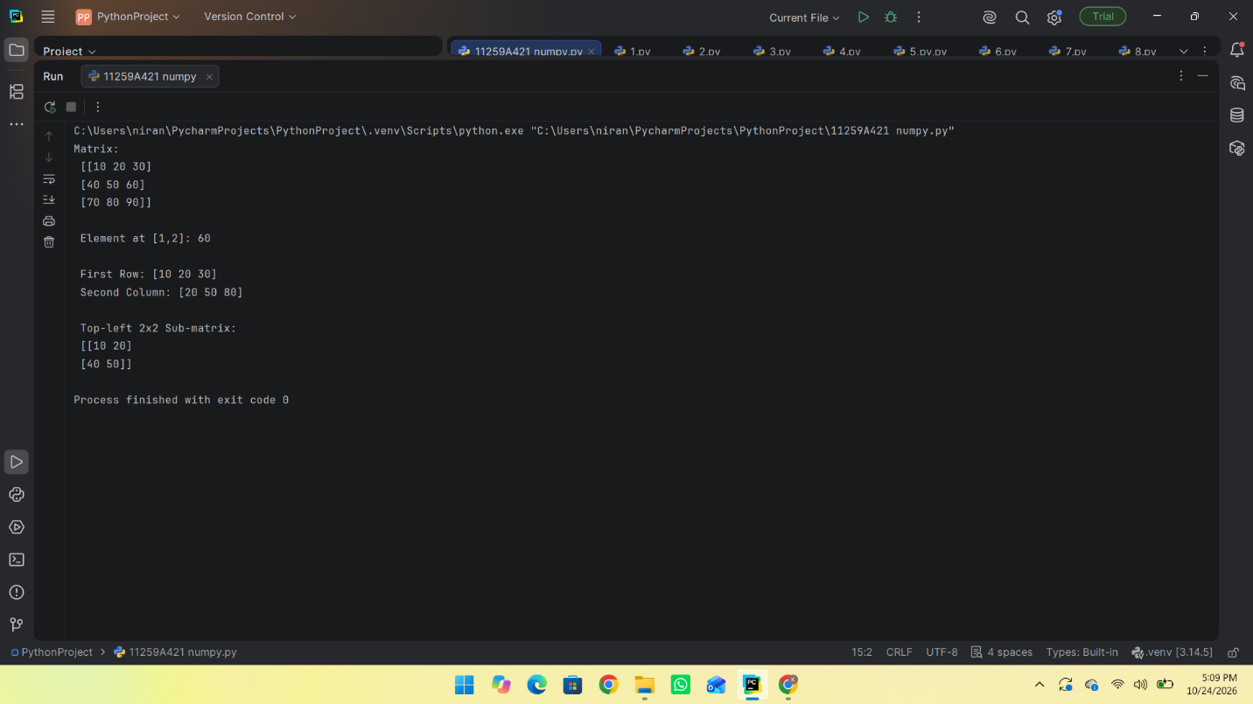

RESULT: Thus, the Python program to access matrix elements, extract rows and columns, and obtain a sub-matrix using NumPy indexing and slicing was executed successfully

